Assignment-6

321910302051

K.Kalyani

1. **Program to convert binary number into decimal number**

b_num = list(input("Input a binary number: "))

value = 0

i in range(len(b_num)):

digit = b_num.pop()

if digit == '1':

value = value + pow(2, i)

print("The decimal value of the number is", value)

**Output:-**

Input a binary number: 11011001

The decimal value of the number is 217

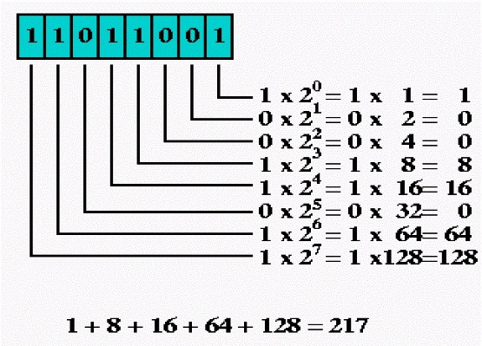 **Pictorial Presentation:**

1. **Program to generate first n number of fibonacci numbers**

**n = int(input("Enter the value of 'n': "))**

**a = 0**

**b = 1**

**sum = 0**

**count = 1**

**print("Fibonacci Series: ", end = " ")**

**while(count <= n):**

**print(sum, end = " ")**

**count += 1**

**a = b**

**b = sum**

**sum = a + b**

**Output:- Enter the value of 'n': 10**

**Fibonacci Series: 0 1 1 2 3 5 8 13 21 34**

1. **Program to display the multiplication table of a value(k)**

**num = int(input("Display multiplication table of "))**

**for i in range(1, 11):**

**print(num, 'x', i, '=', num*i)**

**Outut:- Display multiplication table of 10**

**10 x 1 = 10**

**10 x 2 = 20**

**10 x 3 = 30**

**10 x 4 = 40**

**10 x 5 = 50**

**10 x 6 = 60**

**10 x 7 = 70**

**10 x 8 = 80**

**10 x 9 = 90**

**10 x 10 = 100**

1. **Program to take 10 integers from keyboard using loop and print their average value on the screen**

**num = int(input('How many numbers: '))**

**total_sum = 0**

**for n in range(num):**

**numbers = float(input('Enter number : '))**

**total_sum += numbers**

**avg = total_sum/num**

**print('Average of ', num, ' numbers is :', avg)**

**Output:- How many numbers: 10**

**Enter number : 2**

**Enter number : 4**

**Enter number : 6**

**Enter number : 8**

**Enter number : 10**

**Enter number : 12**

**Enter number : 14**

**Enter number : 16**

**Enter number : 18**

**Enter number : 20**

**Average of 10 numbers is : 11.0**

1. **Program to print the pattern**

**k = 1**

**for i in range(0, 4):**

**for j in range(0, k):**

**print("* ", end="")**

**k = k + 1**

**print()**

**Output:-**

**\***

**\* \***

**\* * \***

**\* * * \***

1. **Program to find H.C.F or G.C.D of two numbers**

**def compute_hcf(x, y):**

**if x > y:**

**smaller = y**

**else:**

**smaller = x**

**for i in range(1, smaller+1):**

**if((x % i == 0) and (y % i == 0)):**

**hcf = i**

**return hcf**

**num1 = 54**

**num2 = 24**

**print("The H.C.F. or G.C.D is", compute_hcf(num1, num2))**

**Output:-**

**The H.C.F. or G.C.D is 6**

1. **Program that accepts a word from user and reverse it**

**word = input("Input a word to reverse: ")**

**for char in range(len(word) - 1, -1, -1):**

**print(“reverse word is “,word[char], end="")**

**print("\n")**

**Output:-**

**Input a word to reverse: GITAM UNIVERSITY**

**reverse word is YTISREVINU MATIG**

1. **Program to count the no.of even and odd numbers from a series of numbers**

**numbers = (1, 2, 3, 4, 5, 6, 7, 8, 9,10,11,12,13,14,15)**

**count_odd = 0**

**count_even = 0**

**for x in numbers:**

**if not x % 2:**

**count_even+=1**

**else:**

**count_odd+=1**

**print("Number of even numbers :",count_even)**

**print("Number of odd numbers :",count_odd)**

**Output:-**

**Number of even numbers : 7**

**Number of odd numbers : 8**

1. **Program that prints all the numbers from 0 to 6 except 3 and 6**

**for x in range(6):**

**if (x == 3 or x==6):**

**continue**

**print(x,end=' ')**

**print("\n")**

**Output:-**

**0 1 2 4 5**